Course Project - SQL Server With Business Intelligence

Shaun Pritchard

Rasmussen College

QMB4200

Terry Brookhouser

October 15, 2020

**Course Project - SQL Server With Business Intelligence**

Here is the login to the created SQL server and Db.

*Note: I had to configure firewall permissions to access it. Then I ran a query to test the database.*

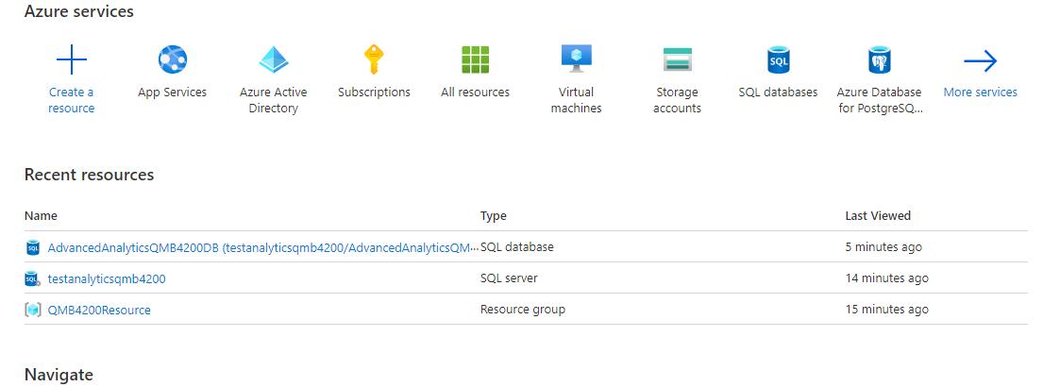

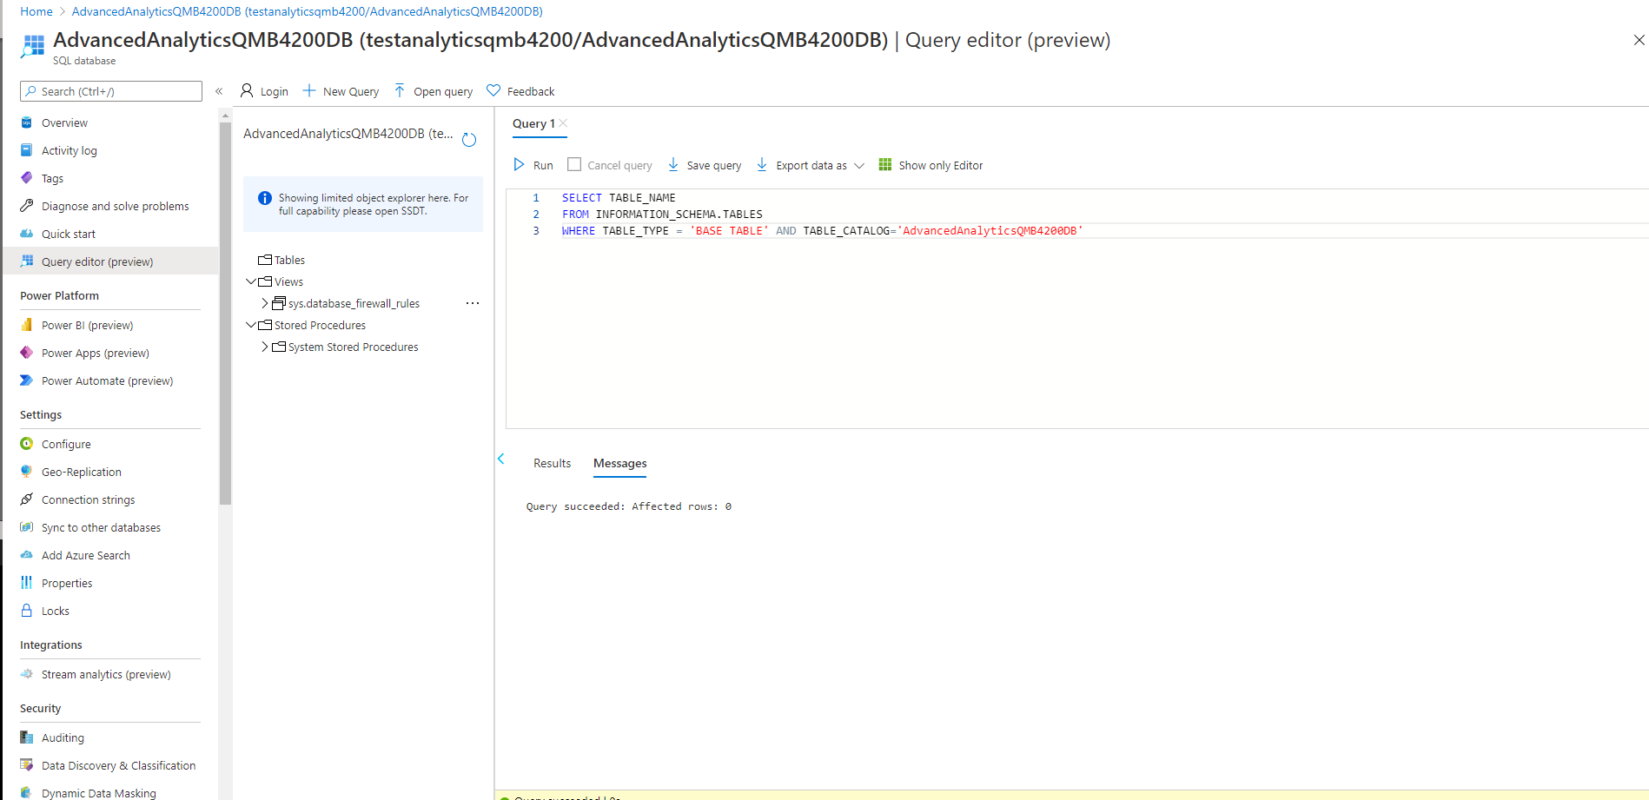

SQL Server Studio login successful:

